Rat Dissection Lab
Team Members:___________________ _____________________ ____________________ _____________________
My Name: ______________________
Introduction
In this laboratory exercise, the anatomy of the rat will be examined in some detail. You may recall that in the grade 10 science, biology unit you dissected a grass frog. You may recognize and remember structures that you learned during that dissection. In Biology 11, a much more detailed look at mammalian anatomy will be conducted. You will get to know and love your preserved rat over the course of this dissection.
The classification of the Rat ( Rattus norvegicus)
Kingdom Animalia
Phylum Chordata
Subphylum Vertebrata
Class Mammalia
Order Rodentia
Family Muridae
Genus Rattus
Species norvegicus
The lab manual and diagrams available to you are supplemental. You are expected to follow the directions during this lab and locate all the required structures. You are expected to have exhausted all possibilities in attempting to locate structures before asking for assistance. Using the available material, instructions and diagrams, most students will be able to locate many structures for themselves. If after an earnest effort, you cannot find a structure, ask for assistance. Remember, this is a learning experience; it is quite permissible to discuss and observe other students' specimens. Compare your dissection with others, animals often differ and be sure to look at animals of the opposite sex You will be responsible for both sexes on the lab practical (the bell ringer).
The specimen you will receive is a preserved double-injected specimen. Double injected refers to the arteries being filled with a red latex, and the veins being filled with blue latex. You will notice various incisions on the external surface of the rat where the latex was injected.
The rat is a vertebrate, which means that many aspects of its structural organization are common with all other vertebrates, including humans. The similarity of structures among related organisms shows evidence of common ancestry. In a way, studying the rat is like studying a human. As the leading theme of this lab, ask yourself: for every structure observed in the rat, there is an equivalent structure in your own body - what is the structure and where is it located in you.
As the second leading theme, pay particular attention to the relationships among organs and groups of organs. Structural parts are not "just there" in random locations. Their specific layout within the body contributes to making certain functions possible. Therefore, for every structure seen, you should determine the following:
- What organ system it belongs to
- How it is connected with other components
- Its general function
- Its specific function (if applicable)
Dissection
Dissecting tools will be used to open the body cavity of the rat and observe the structures. Keep in mind that dissecting does not mean "to cut up"; in fact, it means "to expose to view". Careful dissecting techniques will be needed to observe all the structures and their connections to other structures. You will not need to use a scalpel. Contrary to popular belief, a scalpel is not the best tool for dissection. Scissors serve better because the point of the scissors can be pointed upwards to prevent damaging organs underneath. Always raise structures to be cut with your forceps before cutting, so that you can see exactly what is underneath and where the incision should be made. Never cut more than is absolutely necessary to expose a part.
Grading
Your grade on this laboratory will be assessed according to the following criteria
- Class Participation (serious approach, proper cleanup and lab safety)
- Lab Checklist
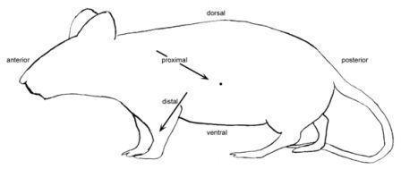
- Quizzes throughout
- Lab Practical Exam (Bell-Ringer)
Glossary of Terms
Dorsal: toward the back
Ventral: toward the bellyLateral: toward the sides
Median: near the middle
Anterior: toward the head
Posterior: toward the hind end (tail)
Superficial: on or near the surface
Deep: some distance below the surface
Sagittal: relating to the midplane which bisects the left and right sides
Transverse: relating to the plane separating anterior and posterior
Horizontal: relating to the plane separating dorsal and ventral
Proximal: near to the point of reference
Distal: far from the point of reference
Caudal: toward the tail end
Pectoral: relating to the chest and shoulder region
Pelvic: relating to the hip region
Dermal - relating to the skin
Longitudinal - lengthwise
Right & Left - refers to the specimen's right and left, not yours
Abdominal Cavity - related to the area below(posterior) the ribcage
Thoracic Cavity - related to the area above(anterior) the ribcage.

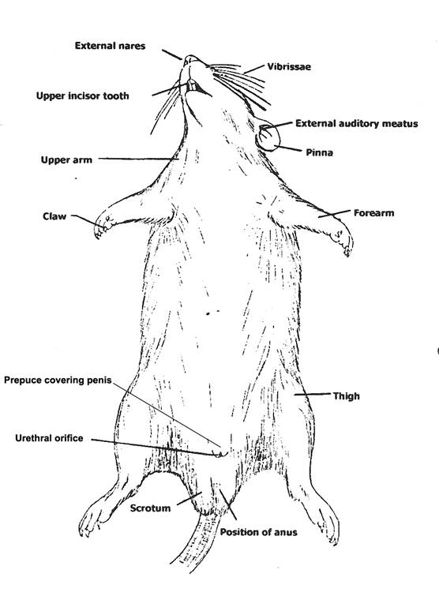
Part 1:Rat External Anatomy
Day 1
Procedure: Obtain your rat. Rinse it off with water and place it in your dissecting pan to observe the general characteristics. Make sure you know the meaning and location of each of the highlighted words below.
The rat's body is divided into six anatomical regions:
cranial region - head
cervical region - neck
pectoral region - area where front legs attach
thoracic region - chest area
abdomen - belly
pelvic region - area where the back legs attach
- Note the hairy coat that covers the rat and the sensory hairs (whiskers) located on the rat's face, called vibrissae.
2. The mouth has a large cleft in the upper lip which exposes large front incisors. Rats are gnawing mammals, and these incisors will continue to grow for as long as the rat lives.
3. Note the eyes with the large pupil and the nictitating membrane found at the inside corner of the eye. This membrane can be drawn across the eye for protection. The eyelids are similar to those found in humans.
4. The ears are composed of the external part, called the pinna, and the auditory meatus, the ear canal.
5. Locate the teats on the ventral surface of the rat. Check a rat of another sex and determine whether both sexes have teats.
6. Examine the tail;, the tails of rats do not have hair. Though some rodents, like gerbils, have hair on their tails.
7. Locate the anus, which is ventral to the base of the tale.
8. On female rats, just posterior to the last pair of teats, you will find the urinary aperture and behind that the vaginal orifice which is in a small depression called the vulva.
9. On males, you will find a large pair of of scrotal sacs which contain testes. Just anterior to the scrotal sacs is the prepuce, which is a bulge of skin surrounding the penis. The end of the penis has a urogenital orifice, where both urine and sperm exit.
Male rat

Identify the following organs/structures and complete the table below.
 | Organ | Location | Description/Photo | Function
 | Vibrissae
 | Incisors
 | Pupil
 | nictitating membrane
 | Pinna
 | auditory meatus
 | Teats
 | Tail
 | Anus
vaginal orifice/ urogenital orifice
(female)

urinary aperture/ testes
(male)

 | scrotal sacs
 | Vulva (female)./ prepuce (male)

Part 2:Rat Anatomy - Head, Thoracic, and Abdominal Organs

Organs of the Head and Neck
1.Procedure: Skinning the Rat
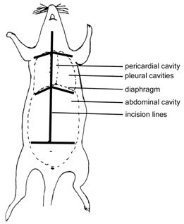
Firstly, pin all four limbs to the dissecting tray. You will carefully remove the skin of the rat to expose the muscles below. This task is best accomplished with scissors and forceps where the skin is gently lifted and snipped away from the muscles. You can start at the incision point where the latex was injected and continue toward the tail. Use the lines on the diagram to cut a similar pattern, avoiding the genital area. Gently peel the skin from the muscles, using scissors and a probe to tease away muscles that stick to the skin. Pin the skin away from the body.
1. Locate the salivary glands, which are on the sides of the neck, between muscles. Carefully remove the skin of the neck and face to reveal these glands. Salivary glands are soft spongy tissue that secrete saliva and amylase (an enzyme that helps break down carbohydrates). There are three salivary glands - the sublingual, submaxillary, and parotid.
2. Find the lymph glands nodes which lie anterior to the salivary glands. Lymph glands are circular and are pressed against the jaw muscles. The primary function of all lymph nodes is the production of lymphocytes, which help defend the body against microorganisms and against harmful foreign particles and debris from lymph before it is returned to the blood stream.
3. After you have located the submaxillary glands, remove them to find the underlying structures.
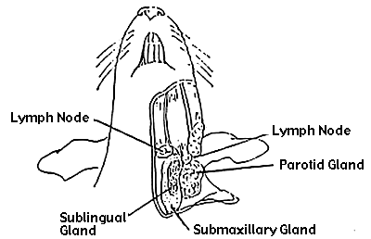
4. The thyroid gland is a gray or brown swelling on either side of the trachea. To locate the trachea you will need to carefully remove the sternohyoid muscles of the neck. The trachea is identifiable by its ringed cartilage which provides support. The esophagus lies underneath the trachea, though it is easier to locate in the abdominal cavity where it enters the stomach.

Identify the following organs/structures and complete the table below.
 | Organ | Location | Description/photo | Function
 | Sublingual gland
 | Submaxillary gland
 | Parotid gland
 | lymph glands
 | thyroid gland
The Thoracic Organs
2. Procedure: Cut through the abdominal wall of the rat following the incision marks in the picture. Be careful not to cut too deeply and keep the tip of your scissors pointed upwards. Do not damage the underlying structures. Once you have opened the body cavity, you will need to rinse it in the sink.
1. Locate the diaphragm, which is a thin layer of muscle that separates the thoracic cavity from the abdominal cavity.
2. The heart is centrally located in the thoracic cavity. The two dark colored chambers at the top are the atria (single: atrium), and the bottom chambers are the ventricles. The heart is covered by a thin membrane called the pericardium. (We will come back to the heart later.)
3. Locate the thymus gland, which lies directly over the upper part of the heart. The thymus functions in the development of the immune system and is much larger in young rats than it is in older rats.
4. The bronchial tubes branch from the trachea and enter the lungs on either side. The lungs are large spongy tissue that take up a large amount of the thoracic cavity. Bronchial tubes may be difficult to locate because they are embedded in the lungs.
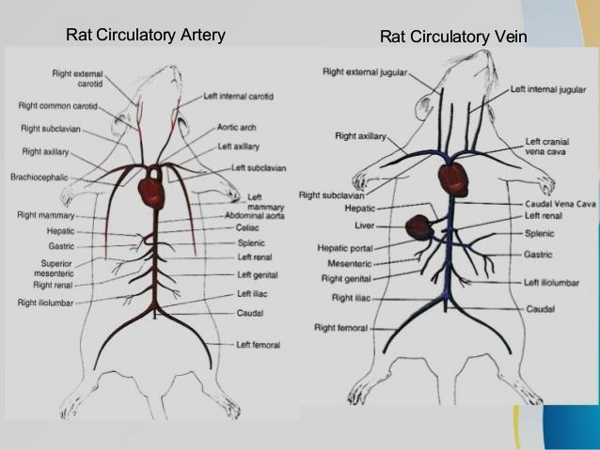

Identify the following organs/structures and complete the table below.
 | Organ/Gland | Location | Description/photo | Function
 | Lungs
 | Heart
 | 2 Atria
 | 2 Ventricles
 | Thymus
 | Trachea
 | Esophagus
 | Aorta
 | Jugular veins
 | Carotid arteries
 | Inferior vena cava
 | Superior vena cava

Day 2

Part 3: The Abdominal Organs
Identify the following organs/structures and complete the table below.
1. The coelom is the body cavity within which the viscera (internal organs) are located. The cavity is covered by a membrane called the peritoneum, which covers three regions
visceral peritoneum - covers the internal organs
mesenteries - attach the internal organs to the dorsal body wall
omentia - connect organ to organ
2. Locate the liver, which is a dark colored organ suspended just under the diaphragm. The liver has many functions, one of which is to produce bile which aids in digesting fat. The liver also stores glycogen and transmforms wastes into less harmful substances. Rats do not have a gall bladder which is used for storing bile in other animals. There are four parts to the liver:
median or cystic lobe - located atop the organ, there is a central cleft
left lateral lobe - large and partially covered by the stomach
right lateral lobe - partially divided into an anterior and posterior lobule, hidden from view by the median lobe
caudate lobe - small and folds around the esophagus and the stomach, seen most easily when liver is raised
3. The esophagus pierces the diaphragm and moves food from the mouth to the stomach. It is distinguished from the trachea by its lack of cartilage rings.
4. Locate the stomach on the left side just under the diaphragm. The functions of the stomach include food storage, physical breakdown of food, and the digestion of protein. The opening between the esophagus and the stomach is called the cardiac sphincter. The outer margin of the curved stomach is called the greater curvature, the inner margin is called the lesser curvature.
5. Slit the stomach lengthwise and notice the ridges, called rugae. The attachment between the stomach and the intestine is called the pyloric sphincter.
6. The spleen is about the same color as the liver and is attached to the greater curvature of the stomach. It is associated with the circulatory system and functions in the destruction of blood cells and blood storage. A person can live without a spleen, but they're more likely to get sick as it helps the immune system function.
7. The pancreas is a brownish, flattened gland found in the tissue between the stomach and small intestine. The pancreas produces digestive enzymes that are sent to the intestine via small ducts (the pancreatic duct). The pancreas also secretes insulin which is important in the regulation of glucose metabolism. The greater omentum is the membranous curtain of tissue that hangs from the stomach and contains lymph nodes, blood vessels, and fat. Find the pancreas by looking for a thin, almost membrane looking structure that has the consistency of cottage cheese.
8. The small intestine is a slender coiled tube that receives partially digested food from the stomach (via the pyloric sphincter). It consists of three sections: duodenum, ileum, and jejunum.
9. Use your scissors to cut the mesentery of the small intestine, but do not remove it from its attachment to the stomach and rectum. Only cut the mesentery that keeps the small intestine tightly folded to it. If you are careful you will be able to stretch it out and untangle it so that you can see the relative lengths of the large and the small intestine.
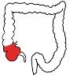
10. Locate the colon, which is the large greenish tube that extends from the small intestine and leads to the anus. The colon is also known as the large intestine. The colon is where the finals stages of digestion and water absorption occurs and it contains a variety of bacteria to aid in digestion. The colon consists of seven sections:
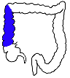
- the cecum - a large sac in the lower third of the abdominal cavity, it is a dead-end pouch and is similar to the appendix in humans. It also is the point at which the small intestine becomes the large intestine.
- The ascending colon - the first main part of the large intestine, which passes upward from the cecum on the right side of the abdomen.
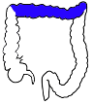
- The transverse colon - The transverse colon's function is to extract water and nutrients from digested foods or materials that pass through the digestive tract. The transverse colon is the longest section of the colon. Its location is across the abdomen, and it forms a connection between the ascending colon and descending colon
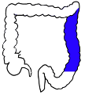
- The descending colon - The descending colon is the part of the large intestine from the splenic flexure to the beginning of the sigmoid colon. The function of the descending colon in the digestive system is to store the remains of digested food that will be emptied into the rectum.
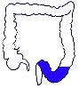
- The sigmoid colon - Sigmoid colon, a terminal section of the large intestine that connects the descending colon to the rectum; its function is to store fecal wastes until they are ready to leave the body.
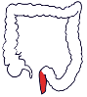
- The rectum - the short, terminal section of the colon between the descending colon and the anus. The rectum temporarily stores feces before they are expelled from the body.
- The anus - The anus is the last part of the digestive tract. It is a 2-inch long canal consisting of the pelvic floor muscles and the two anal sphincters (internal and external). The lining of the upper anusis specialized to detect rectal contents. It lets you know whether the contents are liquid, gas, or solid.
4. Procedure: remove and label each organ of the digestive cavity and carefully examine them and complete the table below.
 | Organ | Location | Description/photo | Function
 | Stomach
 | Small Intestine
 | Large Intestine
 | Appendix
 | Kidneys
 | Liver/gall bladder
 | Pancreas
 | Esophagus
 | Spleen

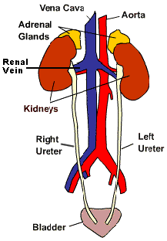
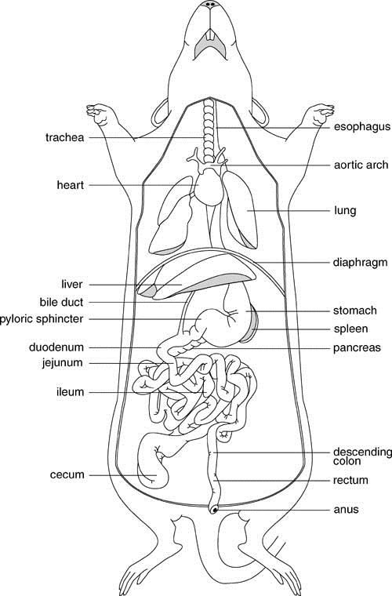

Part 4:Urogenital System
The excretory and reprodutive systems of vertebrates are closely integrated and are usually studied together as the urogenital system. However, they do have different functions: the excretory system removes liquid wastes and the reproductive system produces gametes (sperm & eggs). The reproductive system also provides an environment for the developing embryo and regulates hormones related to sexual development.

Excretory Organs

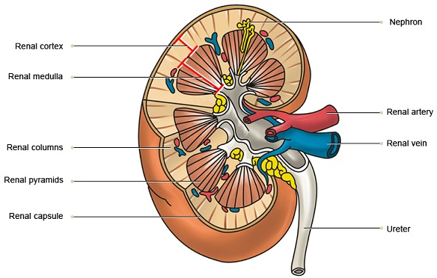
1. The primary organs of the excretory system are the kidneys. These organs are large bean shaped structures located toward the back of the abdominal cavity on either side of the spine. Renal arteries supply the kidneys with blood and the renal veins remove deoxygenated blood.

2. Locate the delicate ureters that attach to the kidney and lead to the bladder. Wiggle the kidneys to help locate these tiny tubes.
3. Procedure: Remove the kidneys (without damaging the other organs) and dissect one by cutting it longitudinally. Locate the cortex (the outer area) and the medulla (the inner area).
3. The urethra carries urine from the bladder to the urethral orifice (this orifice is found in different areas depending on whether you have a male or female rat).
4. The small yellowish glands embedded in the fat atop the kidneys are the adrenal glands.
Complete the table below
 | Organ | Location | Description/photo | Function
 | Kidneys
 | Renal arteries/veins
 | ureters
 | bladder
 | Urethra
 | Adrenal glands

The Reproductive Organs of the Male Rat
1. The major reproductive organs of the male rat are the testes (singular: testis) which are located in the scrotal sac. Cut through the sac carefully to reveal the testis. On the surface of the testis is a coiled tube called the epididymus, which collects and stores sperm cells. The tubular vas deferens moves sperm from the epididymus to the urethra, which carries sperm though the penis and out the body.
2. The lumpy brown glands located to the left and right of the urinary bladder are the seminal vesicles. The gland below the bladder is the prostate gland and it is partially wrapped around the penis. The seminal vesicles and the prostate gland secrete materials that form the seminal fluid (semen).
*Observe both sexes.

The Reproductive Organs of the Female Rat
1. The short gray tube lying dorsal to the urinary bladder is the vagina. The vagina divides into two uterine horns that extend toward the kidneys. This duplex uterus is common in some animals and will accomodate multiple embryos (a litter). In contrast, a simple uterus, like the kind found in humans has a single chamber for the development of a single embryo.
2. At the tips of the uterine horns are small lumpy glands called ovaries, which are connected to the uterine horns via oviducts. Oviducts are extremely tiny and may be difficult to find without a dissecting scope.

4.Procedure: remove and label the organs of the urogenital system.
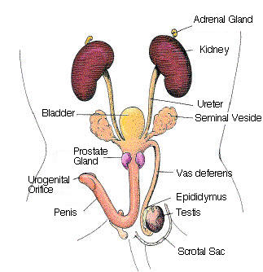 | 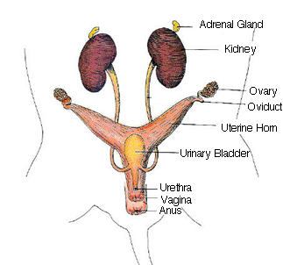

Male Female

Rat Anatomy Checklist
Throughout the course of the dissection, you will be stopped and your teacher will check your progress. At each checkpoint, you should have the box initialed by your teacher to ensure adequate progress. You will turn this sheet in at the end of the investigation.
1. Rat skinned and muscles exposed. [ teacher initials_____________ ]
2. The external anatomy observed and table filled out. [teacher initials _____________ ]
3. Securing with pins of the head and neck. [teacher initials _____________ ]
4. Removing and pinning the organs of the digestive system-table complete. [teacher initials _____________ ]
5. Removal and dissection of the kidney, opening of the stomach and small intestines. [teacher initials _____________ ]
6. Pinning the urogenital organs. [teacher initials _____________ ]
7. Exposing the subclavian, axillary and carotid arteries. [teacher initials _____________ ]
8. Exposing the iliac and femoral arteries. [teacher initials _____________ ]
9. Tidying work area. [teacher initials _____________ ]
Lab Evaluation
Group Members names
____________________________________
___________________________________
___________________________________
_____________________________________
_____________________________________
 | 3 | 2 | 1
FOCUS - embraces lab as a learning opportunity, uses resources to enhance understanding, stays focused and self-directed
PARTICIPATION - shared equally in responsibilities, no absences
COMPLETION - all checkpoints achieved and checklist complete
RESPECT - attentive, curious, does not "play" with the specimen
SAFETY & CLEANUP - always wore goggles, cleaned up station, stored specimen appropriately

